A Multi-Layer Framework for Prompt Injection Detection in Cybersecurity Copilots
Abstract—Large language model (LLM)-based cybersecurity copilots can be exposed to prompt-injection attempts that seek to override instructions or elicit protected information. This paper describes a multi-layer screening gateway combining a word- and character-level Multi-View Network (MVNet), a policy engine, risk fusion, and conditional RoBERTa verification before an input is passed to a local Llama 3.2 3B Instruct model. The gateway uses a 0.30 routing threshold and a 0.50 malicious-probability threshold for RoBERTa. On the repository’s 942-sample test set, the full gateway reports 95.75% accuracy, 97.41% precision, 95.29% recall, and 96.34% F1-score for malicious-input detection. The results describe gateway classification and routing, not end-to-end attack success or data-leakage rates from generated responses. The paper documents the implemented pipeline, evaluates saved prediction artifacts, and identifies limits that should be addressed before deployment.
Index Terms—Prompt injection, large language models, cybersecurity copilot, MVNet, RoBERTa, risk fusion, data leakage prevention.

I. INTRODUCTION
Large language models are increasingly used for security analysis, incident triage, log interpretation, and incident-report drafting. Their ability to follow natural-language instructions makes them useful, but it also creates an attack surface: user-supplied text or documents can contain instructions intended to override the intended task, disclose hidden prompts, or manipulate tool use. A cybersecurity copilot may process logs, emails, PDFs, incident notes, and retrieved documents from sources that are not fully trusted.
Prompt injection is difficult to handle as a simple keyword-filtering problem. The same phrase may be harmless in a discussion about security testing but malicious when it is presented as an instruction to the model. Conversely, an attack may be phrased indirectly or embedded inside otherwise ordinary content. This makes a layered screening design useful: a learned classifier can detect patterns, explicit policy rules can enforce selected constraints, and a second model can inspect inputs that are not considered low risk.
The project described in this paper places a gateway before a local Llama 3.2 3B Instruct model. Text input is processed directly; PDF input is first converted into text. The gateway then applies MVNet, policy checks, risk fusion, and conditional RoBERTa verification. Inputs that pass the gateway are intended to continue to the downstream model. This arrangement creates a defined decision point before generation, although it does not eliminate risks arising from retrieval, tools, model behavior, or output handling.
An important design choice is to treat the gateway as a decision layer rather than as a replacement for the language model. The classifier does not need to generate an answer; it assigns a risk-oriented label and determines whether the input should continue. Keeping these roles separate makes it easier to evaluate the screening component with labeled examples and to debug a decision without mixing classification quality with the quality of a generated response. It also creates a defined place to log the input class, the risk decision, and whether secondary verification was invoked. Such records should be handled carefully so that the logs do not become another source of sensitive-data exposure.

A. Contributions and Scope
The implemented system combines (1) word- and character-level MVNet screening, (2) a rule-based policy engine, (3) risk-based routing with a documented threshold of 0.30, and (4) conditional RoBERTa verification using a 0.50 malicious-probability threshold. The project repository also contains saved test predictions and full-gateway evaluation artifacts. This paper recomputes the standalone classifier metrics from those prediction files and reports the gateway results recorded in the project artifacts.
The evaluation scope is deliberately narrow. Classification metrics indicate whether the gateway labels an input as benign or malicious. They do not directly measure whether a language model reveals a secret, follows a jailbreak, or completes a legitimate task after seeing an adversarial prompt. Such claims require response-level testing and a clear definition of success. Accordingly, the paper does not present the small set of manual checks as a general attack-success-rate or leakage benchmark.
Three questions should be kept separate throughout the evaluation. The first is whether the classifiers distinguish benign and malicious text in the selected dataset. The second is whether the routing logic applies the intended thresholds and produces the expected ALLOW or BLOCK decision. The third is whether the downstream LLM remains safe when it receives adversarial content. The saved prediction files support the first question, and the full-system artifacts support the second. The third requires a separate response-level experiment and is not answered by classification scores alone.

II. RELATED WORK
Pingua et al. introduced Prompt-G, a prompt-based approach aimed at mitigating jailbreak attacks against LLMs [1]. The work provides a relevant point of comparison because it addresses adversarial attempts to manipulate instruction-following models. The present implementation uses a different workflow: it screens incoming content with a supervised classifier, applies policy rules, fuses risk signals, and routes selected inputs to a second classifier.
Zhang et al. survey safety, security, and privacy issues in large language models [2]. These areas overlap but are not identical. Safety relates to harmful or unintended behavior; security includes adversarial manipulation and weaknesses in the surrounding system; privacy concerns exposure or misuse of sensitive information. This distinction matters for evaluation: a model that classifies prompt-injection examples accurately may still require separate tests for generated responses, sensitive-data exposure, and tool permissions.

III. SYSTEM ARCHITECTURE
The input layer accepts text or PDF. PDF content is extracted before preprocessing so that both input types share the same text-based screening path. MVNet then produces a maliciousness estimate using word- and character-level views. The policy engine checks predefined security rules, and risk fusion determines whether the input can take the direct allow path or should receive secondary verification.
The implementation documents two separate thresholds. A fused risk value at or below 0.30 follows the direct ALLOW path. A value above 0.30 is routed to RoBERTa. After secondary verification, a malicious probability greater than or equal to 0.50 results in BLOCK; a probability below 0.50 results in ALLOW. The first threshold controls routing, whereas the second controls the RoBERTa decision.
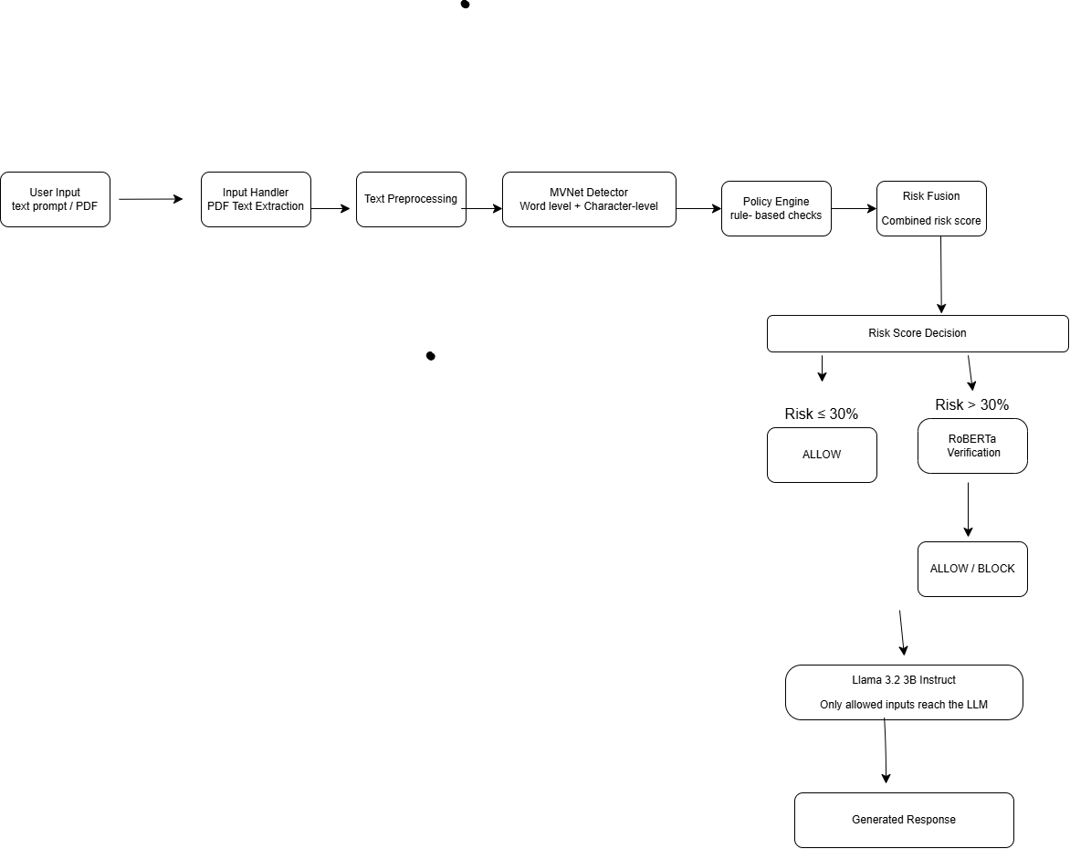
Fig. 1. Architecture of the proposed multi-layer prompt-injection screening gateway.

A. Input Handling and Preprocessing
The system converts PDF content into text before passing it through the screening workflow. This provides a common interface for documents and direct text, but it also makes extraction quality part of the security boundary. If a PDF contains unusual layout, image-only text, or formatting that the extractor does not preserve, the classifier may receive incomplete content. The reported test metrics apply to the repository’s processed text dataset; they do not establish robustness to every PDF layout or extraction error.

B. MVNet First-Stage Classifier
MVNet combines word-level and character-level information. Word-level features represent recognizable lexical units and their context, while character-level features preserve smaller patterns that can remain visible when words are fragmented or unusually spelled. The two views are fused for the initial classification. The saved test predictions yield 95.33% accuracy, 95.68% precision, 96.38% recall, and 96.03% F1-score for the malicious class; the saved model metrics report ROC-AUC of approximately 0.9932.
The architecture offers a practical reason to combine representations: the two views can capture different evidence in the same prompt. However, the available results do not isolate the contribution of each branch. An ablation study comparing word-only, character-only, and fused variants would be needed to quantify the benefit of feature fusion rather than attributing the full performance to any single component.
An informative follow-up experiment would train and test three controlled variants with the same data split: a word-only classifier, a character-only classifier, and the fused MVNet. Each variant should use the same evaluation metrics and comparable training settings. This would show whether the character branch improves robustness, whether the word branch contributes most of the signal, and whether the combined model offers a measurable benefit. The current paper reports only the fused implementation because those are the saved artifacts available for this project.

C. Policy Engine and Risk Fusion
The policy engine complements the learned classifier with predefined rules. This is useful when a deployment needs deterministic checks for specified patterns or policy conditions. Rules are also limited by what has been encoded: a rule set may miss novel wording, and an overly broad rule may block legitimate security work. Decisions should therefore be logged with enough context to support debugging, while avoiding unnecessary retention of sensitive prompt content.
Risk fusion controls the transition between the first-stage classifier and secondary verification. The repository documents the 0.30 routing threshold and conditional use of RoBERTa. This paper reports those implemented settings but does not assign an undocumented mathematical formula to the fusion stage. The threshold should be treated as a tunable operational choice rather than a universal value. Lowering it would generally route more inputs to the second stage; raising it would generally route fewer.
A practical threshold study would sweep the routing threshold across a small set of values while keeping the secondary decision threshold fixed, then measure verification rate, final precision, final recall, and gateway latency. A second experiment could sweep the RoBERTa threshold while keeping routing fixed. This would help distinguish the effect of sending more inputs to the second model from the effect of changing the final malicious/benign decision. Any selected threshold should be fixed before the final held-out evaluation to avoid tuning directly on the test set.

D. RoBERTa Secondary Verification
RoBERTa is applied only to inputs routed for secondary verification. The saved training configuration identifies roberta-base, a maximum sequence length of 128 tokens, batch size 4, two epochs, and a learning rate of 2 × 10⁻⁵. Recalculation from the saved prediction file yields 96.71% accuracy, 95.78% precision, 98.73% recall, and 97.23% F1-score. The ROC-AUC computed from its saved malicious-probability values is approximately 0.9968.
The secondary decision threshold is 0.50. Changing this threshold can change the number of false negatives and false positives. A security-focused application may prefer to reduce missed attacks, but aggressive blocking can interrupt legitimate workflows. The appropriate threshold depends on the application’s threat model, available tool permissions, and cost of each error. It should be selected using held-out evaluation data rather than chosen solely from training performance.

E. Downstream Llama Integration
Allowed inputs are intended to be passed to a local, quantized Llama 3.2 3B Instruct model. Local execution may support a controlled processing environment, but it is not by itself a guarantee of privacy or security. The system prompt, retrieved content, tool access, file permissions, logging, and output filtering remain relevant. The gateway can reduce exposure to known malicious input patterns, but it should be one layer in a broader defense-in-depth design.
The repository’s gateway evaluation focuses on classification and routing rather than generating a Llama response for every test sample. Therefore, the model scores in this paper should not be read as response-safety scores. An end-to-end evaluation would need to submit adversarial inputs to the complete application, record the generated responses, define what constitutes a successful attack, and test whether explicitly protected information appears in the output.

IV. DATASET AND EXPERIMENTAL SETUP
The repository identifies the NeurAlchemy Prompt Injection dataset as its data source. The verification report records 14,036 original training rows, with 102 duplicates removed, leaving 13,934 training examples. The validation split contains 941 examples and the test split contains 942 examples. The training split contains 5,156 benign and 8,778 malicious examples; validation contains 407 benign and 534 malicious examples; test contains 390 benign and 552 malicious examples.
The reported class distribution is not balanced: malicious examples form the majority of each split, including the test partition. As a result, a classifier that favored the majority class could obtain a deceptively reasonable accuracy while failing on benign examples. Reporting precision, recall, F1-score, and the confusion matrix provides a more complete view of the model’s errors. For future comparisons, the paper should also state the exact dataset release or commit and the preprocessing script version so that the source distribution can be reproduced.
Split | Total | Benign | Malicious
Train | 13,934 | 5,156 | 8,778
Validation | 941 | 407 | 534
Test | 942 | 390 | 552
The verification report records zero exact text overlap and zero group-ID overlap between the train, validation, and test partitions. It also records category/label mismatches: 130 in training, 11 in validation, and 9 in test. These mismatches are a data-quality issue that deserves review. If category metadata and binary labels disagree, the team should define which field is authoritative, audit affected examples, and rerun evaluation if labels are corrected.

V. RESULTS
The individual classifier metrics were recomputed from the two saved test-prediction CSVs, using the malicious class as the positive class. The full-gateway values were cross-checked against the saved JSON evaluation artifact. The three rows in Table I represent different evaluation targets: standalone MVNet predictions, standalone RoBERTa predictions, and the complete allow/block gateway.
System | Accuracy | Precision | Recall | F1-score | ROC-AUC
MVNet | 95.33% | 95.68% | 96.38% | 96.03% | 0.9932
RoBERTa | 96.71% | 95.78% | 98.73% | 97.23% | 0.9968
Full gateway | 95.75% | 97.41% | 95.29% | 96.34% | 0.9950
TABLE I. TEST PERFORMANCE OF STANDALONE CLASSIFIERS AND FULL GATEWAY

A. Interpretation of Individual Models
MVNet achieved 95.33% accuracy and 96.03% F1-score. Its 96.38% recall indicates that it identified most malicious examples in its standalone prediction file, while its 95.68% precision indicates that most of its malicious predictions were correct. RoBERTa achieved 96.71% accuracy and 97.23% F1-score. Its recall of 98.73% was higher than MVNet’s recall on the same test split, although its precision was similar. These are standalone classifier results and do not mean that RoBERTa is applied to every sample in the gateway.

B. Full Gateway and Confusion Matrix
The full gateway achieved 95.75% accuracy, 97.41% precision, 95.29% recall, and 96.34% F1-score. Its confusion matrix is shown in Table II. True negatives are benign prompts correctly classified as benign; false positives are benign prompts incorrectly classified as malicious; false negatives are malicious prompts incorrectly classified as benign; and true positives are malicious prompts correctly classified as malicious.
These figures should be read as one operating point, not as a guarantee of future performance. Aggregate precision is relevant to the analyst experience because it describes how often a BLOCK decision corresponds to a malicious example in this test set. Recall is relevant to screening coverage because it describes how many malicious examples were detected. In practice, the preferred balance will depend on whether a false block or a missed attack has the greater cost for the specific copilot workflow.
Actual class | Predicted benign | Predicted malicious
Benign | 376 (TN) | 14 (FP)
Malicious | 26 (FN) | 526 (TP)
TABLE II. CONFUSION MATRIX FOR THE FULL GATEWAY
Out of 552 malicious samples, 526 were detected as malicious and 26 were classified as benign. Out of 390 benign samples, 376 were classified correctly and 14 were classified as malicious. At this operating point, the false-negative rate is 26/552, approximately 4.71%, and the false-positive rate is 14/390, approximately 3.59%. These are rates for this test split only and should not be assumed to hold for other traffic distributions.

C. Routing and Runtime
The full-system artifact records 548 secondary-verification events, equivalent to 58.17% of the 942 test samples; 394 samples followed the first-stage-only path. The gateway evaluation CSV reports 402 ALLOW decisions, 540 BLOCK decisions, and an average gateway time of 10.84 ms. This timing value is reported as the repository’s gateway timing metric. Unless the timing procedure includes Llama generation, it should not be interpreted as total end-to-end latency.

D. Functional Security Checks
The repository includes a small manually specified set of checks covering attack-oriented prompts, leakage-oriented prompts, and benign task-retention prompts. The saved results mark ten attack-oriented prompts as BLOCK and eight leakage-oriented prompts as BLOCK. Ten benign task prompts are marked ALLOW with task_completed=True. These examples help check that the gateway blocks the selected suspicious cases while allowing a small set of legitimate requests.
The checks should not be described as a general attack-success-rate or leakage-rate benchmark. The set is small and manually specified, and the saved CSV does not include a broad evaluation of generated Llama responses for every case. A rigorous leakage evaluation would define protected canary strings or other sensitive test material, submit adversarial prompts through the full application, record outputs, and score whether protected content was exposed. A rigorous attack-success evaluation would also specify the attack families, number of trials, and success criteria.
A stronger protocol would include both direct and indirect injection cases. Direct cases place the adversarial instruction in the user prompt. Indirect cases embed it in a document or retrieved passage that the copilot is asked to analyze. Each case should be tested through the complete application, and the output should be checked for both instruction-following behavior and exposure of protected content. Results should be broken down by attack family and reported with the number of trials, rather than reduced to a single result from a handful of examples.

VI. DISCUSSION
The results show that the two standalone classifiers achieve strong classification scores on the included test split. The complete gateway has slightly different performance because its final decisions are shaped by routing and policy logic rather than by simply copying one standalone classifier’s predictions. The gateway’s precision of 97.41% indicates that most prompts it blocks are malicious in this test set. Its recall of 95.29% also means that some malicious examples are missed, which is important in a security application.
The errors have different operational consequences. A false negative may allow a prompt-injection attempt to reach the downstream model, while a false positive may prevent an analyst from processing a legitimate log or incident report. The acceptable trade-off depends on context. For a copilot with access to sensitive tools, the system may need more conservative handling of high-impact actions than for a read-only summarization task. Policy checks and model thresholds should reflect those differences.
Operationally, the gateway should be monitored after deployment for distribution shifts and unexpected error clusters. A rise in false positives may indicate a new legitimate workflow or an overly broad policy rule. A rise in false negatives may indicate new attack phrasing, preprocessing drift, or a mismatch between live traffic and the training dataset. Monitoring should use privacy-aware aggregates where possible and should not retain raw sensitive prompts longer than necessary. When an error is corrected, the example can be considered for a reviewed regression set.
The secondary-verification rate is another practical factor. RoBERTa was invoked for 58.17% of the test samples, meaning conditional verification is used frequently under the current routing configuration. The threshold could be tuned to reduce unnecessary calls, but it should not be optimized for speed alone. Any adjustment should be compared on recall, precision, false-positive rate, false-negative rate, and latency, using the same held-out test data or a separate validation set.

A. Dataset Quality and Generalization
The verification report notes category/label mismatches in every split. Even when exact text overlap is zero, inconsistent labels can affect what a model learns and how its evaluation should be interpreted. A data audit should inspect mismatched examples and document whether the binary label or category field is authoritative. After corrections, training and evaluation should be rerun rather than retroactively changing reported scores without recording the change.
Generalization also remains an open question. Prompt-injection language changes over time, and attacks may use indirect instructions, multilingual text, unusual formatting, or content embedded in retrieved files. A test set drawn from the same source distribution may not represent these conditions. The next evaluation should include an external or temporally separated dataset and report results by attack family, rather than relying only on one aggregate score.

B. Reproducibility and Operational Logging
The repository includes training scripts, model artifacts, prediction files, and evaluation outputs. Those artifacts support recalculation of the metrics reported here. Reproducibility would be improved further by recording exact package versions, random seeds, preprocessing versions, hardware, model checkpoints, and the command used for each evaluation. The system should also log the decision path—direct allow, secondary verification, or block—so false positives and false negatives can be reviewed. Logs must be designed to avoid storing unnecessary sensitive input content.

VII. LIMITATIONS
The findings should be interpreted within the scope of the available artifacts. First, the test set contains 942 examples from the dataset included in the repository; it does not establish generalization to unseen attack families, different languages, heavily obfuscated prompts, indirect prompt injection in retrieved documents, or real enterprise traffic. Second, the verification report identifies category/label mismatches in training, validation, and test data. An audit may change the data and therefore change the scores.
Another limitation is that the aggregate scores do not show performance for every type of prompt injection separately. A model may perform well on common direct instructions while struggling with indirect instructions hidden inside a document, multi-turn attacks, or prompts that combine benign and adversarial content. The current saved artifacts do not provide a complete per-family breakdown, so the paper does not infer one. A future evaluation should group examples by attack technique and report the number of samples in each group so that a strong aggregate result does not hide a weak category.
Third, the gateway evaluation measures classification and routing. It does not by itself demonstrate that the downstream LLM cannot be jailbroken or that sensitive information will never be exposed. Fourth, the manually specified functional checks are useful sanity tests but too small to support broad statistical claims about attack success or leakage. Fifth, the average gateway timing value may not include full LLM generation latency. Finally, the results depend on threshold settings and the balance of benign and malicious examples in the test set.

VIII. CONCLUSION AND FUTURE WORK
This paper described a multi-layer prompt-injection screening gateway that combines MVNet, a policy engine, risk fusion, conditional RoBERTa verification, and integration with a local Llama 3.2 3B Instruct model. On the repository’s 942-sample test set, the complete gateway achieved 95.75% accuracy, 97.41% precision, 95.29% recall, and 96.34% F1-score for malicious-input detection. The confusion matrix contained 376 true negatives, 14 false positives, 26 false negatives, and 526 true positives.
The implementation offers a clear screening path before LLM generation, but the results should be understood as gateway-classification evidence rather than a complete security guarantee. Future work should evaluate a larger and more diverse set of attacks, include indirect prompt injection and multilingual cases, audit inconsistent labels, and perform end-to-end tests of actual Llama responses. Those tests should use explicitly defined protected data, documented success criteria, confidence intervals, and latency measurements on specified hardware. Threshold-sensitivity and ablation experiments would also help establish which components contribute most to security and efficiency.
Before deployment, the gateway should be tested as part of the actual application rather than only as a classifier. The test plan should include PDF extraction, preprocessing, routing, the ALLOW/BLOCK response, and the downstream model call for allowed inputs. It should also verify that a blocked input cannot continue through an alternate route and that exceptions or malformed documents fail safely. These checks are engineering recommendations for future validation; they are not claimed as completed experiments in the current repository.
Future evaluation should also report confidence intervals or repeated-run variation where training randomness affects results. A single score to two decimal places can look more certain than the experiment warrants, particularly when the test set is modest in size. For deployment claims, a temporally separated dataset and an independently sourced test set would be valuable. Finally, evaluation should include a baseline with only MVNet and a baseline with a fixed rule engine so that the value added by risk fusion and conditional RoBERTa can be quantified.
A useful evaluation matrix would compare at least four configurations: MVNet alone, MVNet plus policy rules, the complete risk-fusion gateway without secondary verification, and the full gateway with conditional RoBERTa. Each configuration should be run on the same held-out examples. This would help identify whether the improvement comes from the second model, the policy engine, or the routing strategy. The team should preserve the test set until thresholds and components have been selected on validation data, then use the test set only for the final comparison.
A deployment-oriented test suite should also include malformed and unusually long inputs, empty extracted text, repeated instructions, and prompts that contain quoted attack examples for analysis rather than execution. These cases are important because a filter should not treat every mention of an attack phrase as an attack. The expected behavior should be written down before testing so that the team can distinguish a genuine false positive from a policy decision that was intended by design. Where the correct outcome is ambiguous, the case should be marked for manual review instead of silently being used as a definitive label. The system should also define how failures are handled. If PDF extraction fails or the classifier cannot produce a valid score, the application should not accidentally bypass the screening stage. A conservative fallback may block the input or ask the user to submit plain text, depending on the intended workflow. This behavior needs to be tested explicitly, because the model’s classification metrics do not cover infrastructure failures. Similar checks should confirm that the final ALLOW/BLOCK decision is the one enforced by the application interface and that downstream generation is not invoked after a BLOCK decision. Finally, the results should be maintained as a reproducible experiment record. Each run should identify the dataset split, checkpoint, thresholds, preprocessing version, and software environment. When a new model is trained, the previous checkpoint and metrics should be retained so that performance changes can be traced to a specific modification. This practice is particularly useful for security systems, where a small improvement in one aggregate score may be accompanied by a regression on a specific class of attack. These recommendations describe future validation work; they are not additional measured results from the current test set.

REFERENCES
[1] B. Pingua et al., “Mitigating adversarial manipulation in LLMs: a prompt-based approach to counter jailbreak attacks (Prompt-G),” PeerJ Computer Science, vol. 10, Art. no. e2374, 2024, doi: 10.7717/peerj-cs.2374.
[2] R. Zhang, H.-W. Li, X.-Y. Qian, W.-B. Jiang, and H.-X. Chen, “On large language models safety, security, and privacy: A survey,” Journal of Electronic Science and Technology, vol. 23, Art. no. 100301, 2025, doi: 10.1016/j.jnlest.2025.100301.

